A Report on

## Data Visualization Project

Topic

**Crimes in Cities of Florida**

Submitted By

**Yesha Desai**

(U01726106)

**Index**

|  |  |
| --- | --- |
| **Sr no.** | **Topic** |
| 1. | Introduction |
| 2. | Methodology |
| 3. | Analysis |
| 4. | Conclusion |

**Introduction**

1. **Problem Definition**

The project aims to analyze crime trends and patterns across various cities in Florida by leveraging different datasets. By integrating these datasets, the research seeks to uncover correlations between demographic factors such as median age, gender distribution, and population size, and various types of reported crimes in Florida cities.

Additionally, the study aims to identify patterns in crime rates over time and across different regions of the state. The goal is to provide insights that can inform evidence-based strategies for crime prevention, law enforcement resource allocation, and community safety initiatives tailored to the unique characteristics of each city in Florida.

The project has combined the data from multiple sources like Kaggle and tableau public, and has gathered three different datasets which has various information related to cities of Florida.

1. **Research Questions**

* What are the various categories of criminal offenses prevalent in Florida, and which type of crime stands out as the most frequent or predominant?
* Can a correlation be established between the median age and crime rates across cities in Florida?
* What are the specific types of crimes reported in each city throughout Florida?
* Is there a discernible correlation between the male population and instances of rape crimes in Florida cities?
* Is there a relationship between the occurrence of motor vehicle theft and the total population size in Florida cities?
* How does property crime correlate with the total population across cities in Florida?
* Is there any correlation between the number of robbery crimes reported and the average household size in Florida cities?
* Which cities in Florida are identified as safe based on crime statistics?

**Methodology**

1. **Datasets**:

The project utilizes three distinct datasets sourced from different platforms to investigate various aspects of crime and demographics in Florida cities. The first dataset is obtained from Kaggle which provides comprehensive demographic information about cities across the United States, enabling a detailed analysis of population characteristics. The second dataset, sourced from Tableau Public, specifically focuses on crimes reported in Florida, offering insights into the types and frequencies of criminal incidents within the cities of Florida. And, the third dataset is also from Tableau Public which highlights safe cities within Florida, allowing for comparisons and assessments of safety rankings across different regions.

By integrating these datasets, the research aims to explore correlations between demographic factors and crime rates, identify patterns in crime dynamics, and assess the safety landscape in Florida cities.

Dataset References:

Dataset 1: US cities demographics: https://www.kaggle.com/datasets/mexwell/us-cities-demographics

Dataset 2: Crimes in Florida: https://public.tableau.com/app/profile/cory.nix/viz/FloridaCrimeStatastics2019/Dashboard1  
Dataset 3: Safe cities in Florida: https://public.tableau.com

**Analysis**

To tackle the research questions, I utilized Power BI, a robust data analysis tool, to leverage the sourced datasets effectively. Upon importing the data, I meticulously carried out necessary transformations to ensure its compatibility for analysis. After combining the datasets, I could examine everything together. Using Power BI, I created various visuals like charts and graphs, each focusing on different research questions. These visuals helped me understand the data better, especially when looking at crime and demographics in Florida cities. These visualizations not only facilitated the extraction of meaningful insights but also helped in presenting the findings coherently. Moreover, I developed two concise dashboards and a map visualization to communicate the outcomes.

The visualizations produced in Power BI not only addressed the research questions but also provided actionable insights to inform decision-making processes effectively. The combination of insightful data visualizations and intuitive dashboards offered a comprehensive understanding of the dynamics between demographics, crime rates, and safety rankings in Florida cities.

Below are the visualizations done in PowerBI.

Visualizations:

1. What are the various categories of criminal offenses prevalent in Florida, and which type of crime stands out as the most frequent?

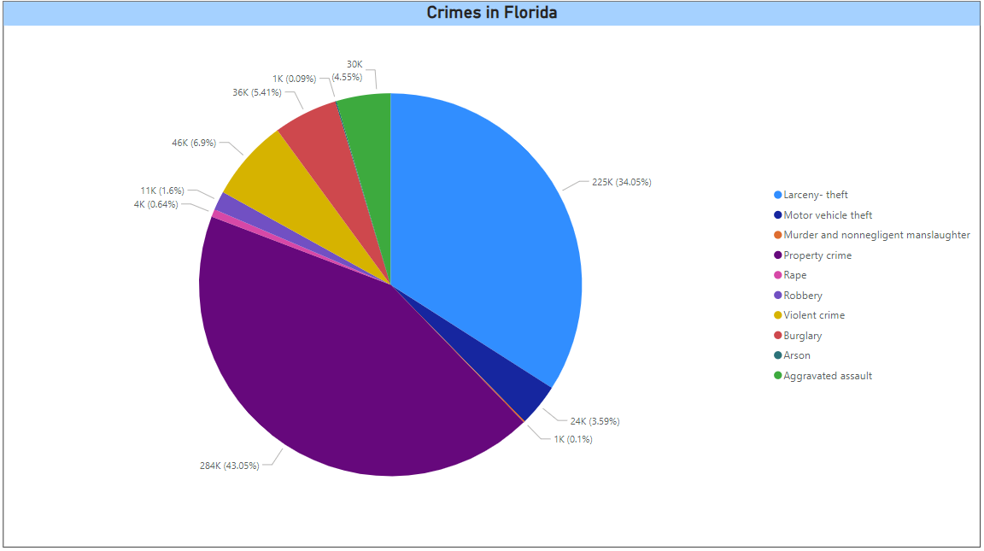

This visualization shows various categories of criminal offenses prevalent in Florida, and the type of crime which is the most frequent, and it shows that Property crime is the highest, following larceny theft crime as the second largest in this pie chart. I have chosen pie chart for this visualization as it clearly depicts proportion of different crimes committed in Florida.

1. Can a correlation be established between the median age and crime rates across cities in Florida?

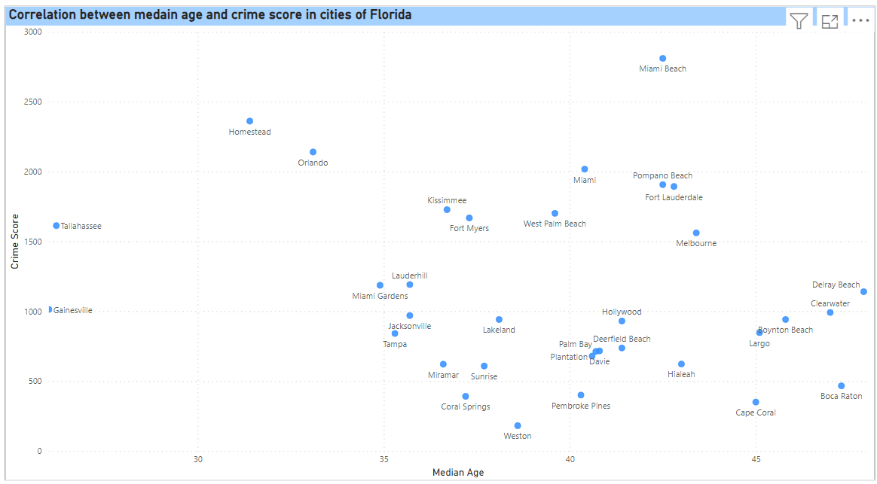

This visualization shows a correlation between median age and crime score in cities of Florida and this depicts that there is a correlation between the both till some extent as it shows that, cities which has higher crime score, it also has same median age. While, cities which has low crime score, has similar median age of all those of low crime score cities.

I have used scatter plot for this visualization because, both median age as well as crime score are being compared and checked and this scatter plot shows a good depiction of it with cities added in label.

1. What are the specific types of crimes reported in each city throughout Florida?

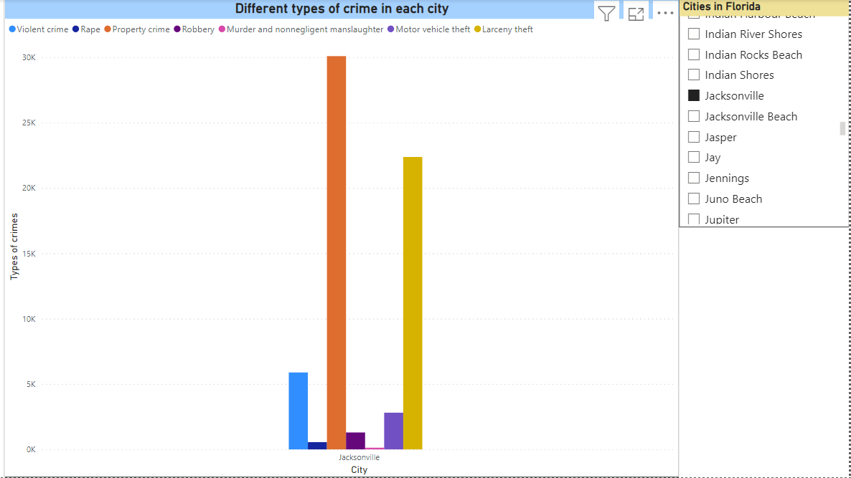

This visualization shows different types of crimes committed in each city of florida. I have used a bar chart to showcase different types of crimes in each city and to clearly understand and look for each city in detail, I have added a slicer as a filter and added cities column in slicer, with which the user can choose any city and check the crimes committed in that city. The above bar chart shows types of crimes for Jacksonville city, with property crime being the highest, following larceny theft and it shows Murder and non-negligence manslaughter as the lowest crime occurred.

1. Is there a discernible correlation between the male population and instances of rape crimes in Florida cities?

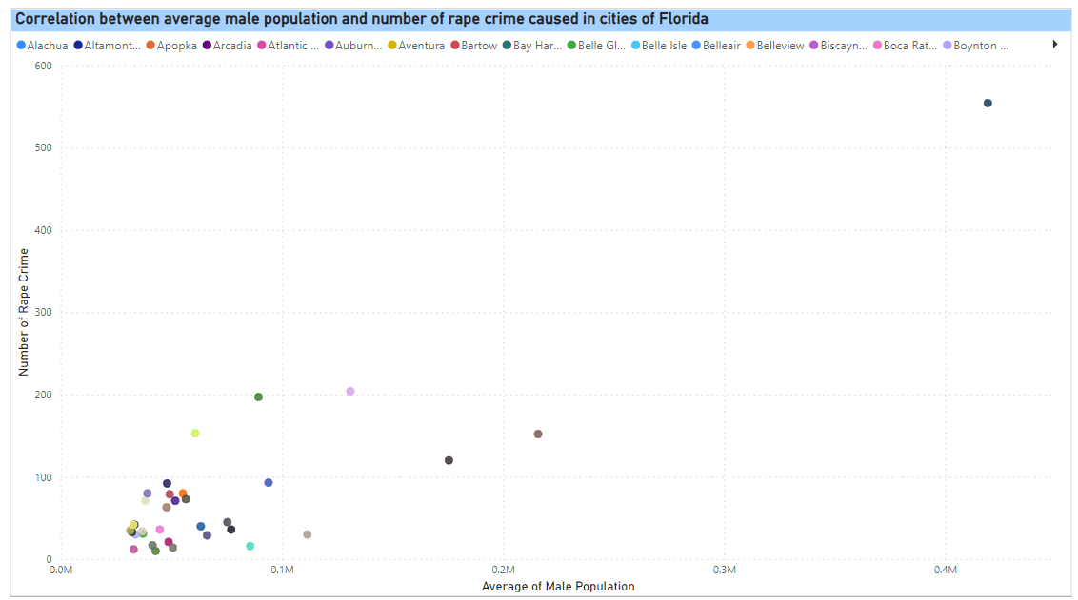

This visualization shows a correlation between average male population and number of rape crime caused in cities of Florida, and the analysis shows that yes, there is a correlation as it is seen that, cities having higher male population, number of crimes committed are also in higher number and cities like Weston, having less male population, rape crime is committed less comparatively. I have used scatter plot for this visualization, because both the columns are being compared and checked.

1. Is there a relationship between the occurrence of motor vehicle theft and the total population size in Florida cities?

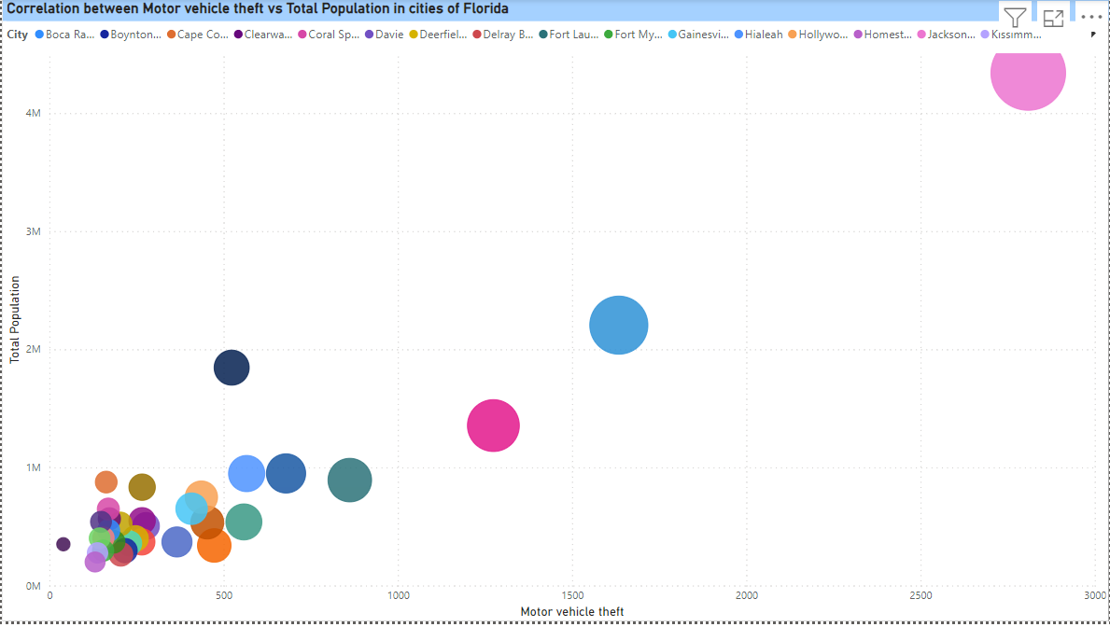

This visualization shows the correlation between motor vehicle theft and total population of all the cities, and the analysis shows that there is a relation between the both as cities having higher population would tend to have more vehicles and therefore, it resulted that vehicle theft is also higher in that city. Similarly, cities having less population resulted in less vehicle theft. I have again used scatter plot to showcase the comparision and check for correlation.

1. How does property crime correlate with the total population across cities in Florida?

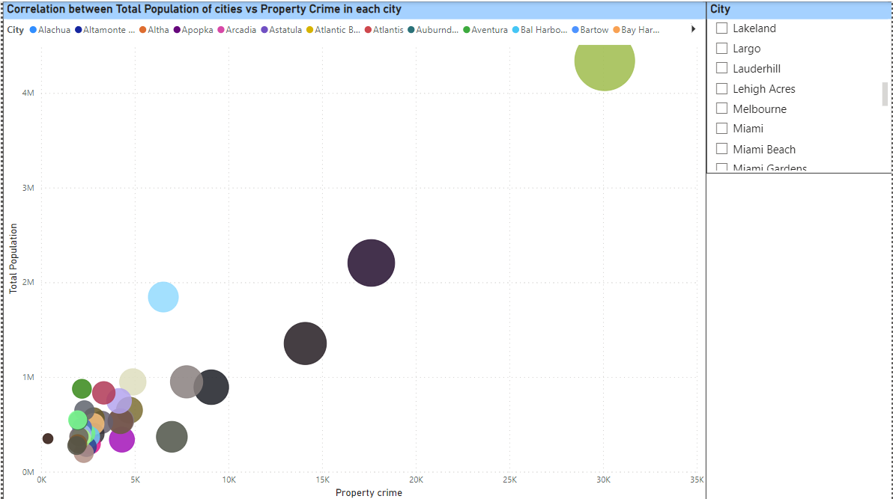

This visualization analysis correlation between total population of cities and property crime in each city and it shows that greater the population, more property crime are taking place in cities, and as the chart shows, scatter plots in bigger size denotes cities having high property crime where as plots in small size are having less property crime. And I have used this chart because the size of plot clearly shows the analysis and the slicer is used to check for city information.

1. Is there any correlation between the number of robbery crimes reported and the average household size in Florida cities?

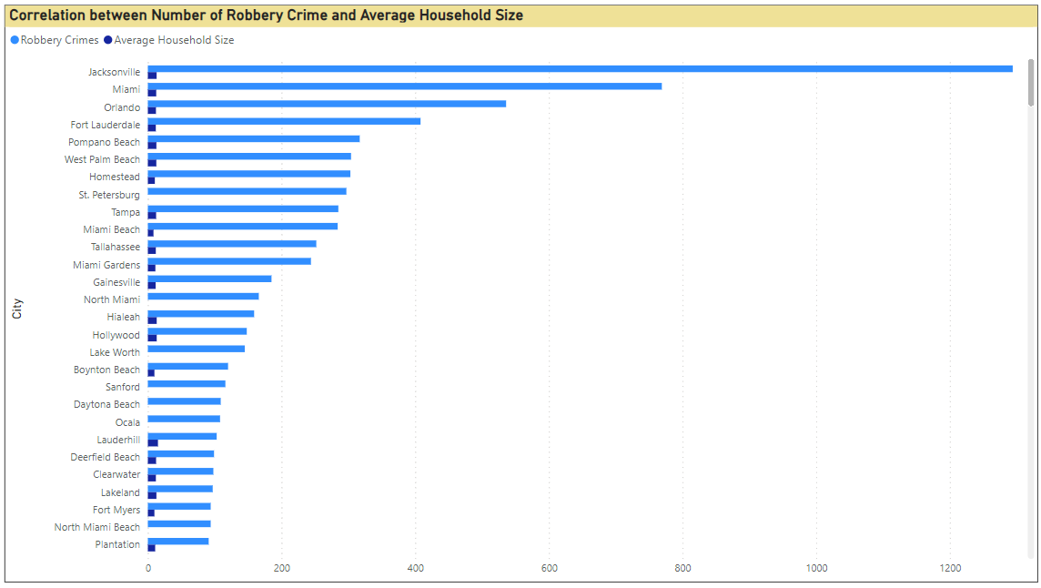

This visualization analysis correlation between number of robbery crime and average household size and it shows that cities having higher household size, are also having higher robbery crime. I have used horizontal bar chart as it shows two measures which can be differentiated easily. The above chart shows that city Jacksonville has highest robbery crime and its average household size is also greater as compared to other cities household size.

1. Which cities in Florida are identified as safe based on crime statistics?

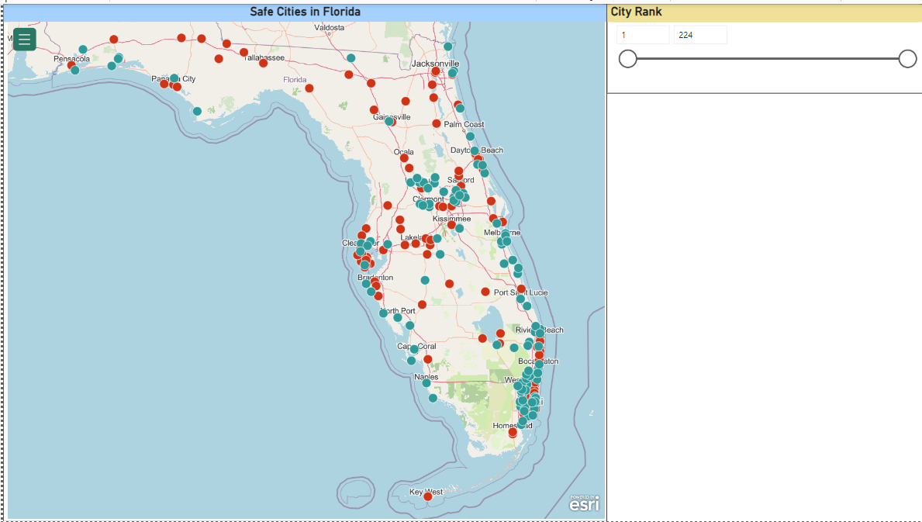

This Map visualization shows safest cities and unsafe cities in florida. The map shows safe cities in green and unsafe cities in red dots. And the map also has a slicer which has the rank of each city. Therefore, the user can change the range of the rank and the map will change accordingly and show the safe and unsafe cities. I have used map visualization as it creates an interactive and easy view of cities being safe through the map.

Dashboard 1:

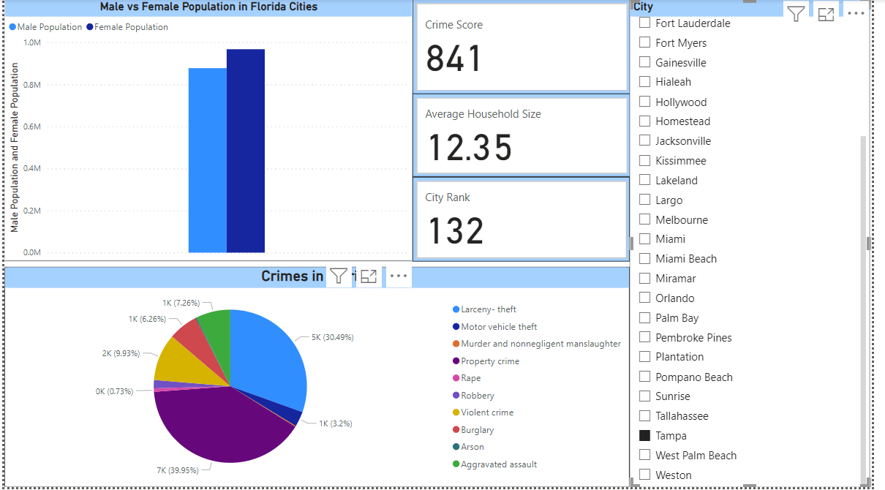

The above dashboard gives an overview of crime statistics in each city, therefore, city being in the slicer. The user can choose a city they want to view the analysis of. The dashboard also shows crime score of that city, rank of the chosen city, average household size and male and female population of that city. It mainly shows the types of crime committed in that city. Therefore, this dashboard gives an overview of crime and city dynamics in each city. The above dashboard shows the overview of city Tampa. Tampa has a crime score of 841, it is ranked 132 for the safe city. The average household size is 12.35 of Tampa and it shows that female population is greater than male population. The major crimes committed in Tampa are property crime, larceny theft, aggravated assault, burglary, etc.

Dashboard 2:

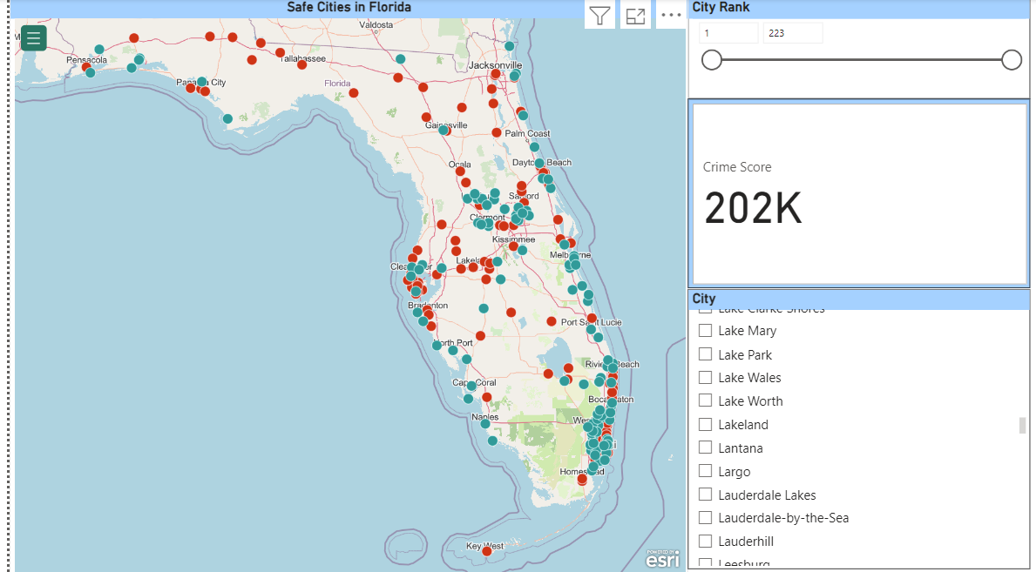

This dashboard gives an overview of safe and unsafe cities in florida based on the city rank as well as it provides the crime score of the chosen city from the slicer. It gives an overall analysis of crimes happening in cities of florida and which cities are safe.

**Conclusion**

In conclusion, the visualizations generated through Power BI effectively addressed the research questions, providing clear and insightful conclusions. Each visualization was carefully crafted to focus on specific aspects of crime dynamics in Florida, ensuring relevance and clarity. The appropriateness of visualization techniques, such as bar charts, pie charts, and scatter plots, facilitated the exploration of various categories of criminal offenses and correlations between demographic factors and crime rates.

The analysis revealed several key findings: a diverse range of criminal offenses exists in Florida, with certain types of crimes: Property crime, Larceny theft crime, etc. standing out as more prevalent than others. Additionally, correlations between median age, male population, and instances of specific crimes were identified, focusing on potential demographic influences on crime rates. Moreover, visualizations effectively highlighted safe cities based on crime statistics, providing valuable insights for policymakers and law enforcement agencies.

In summary, the visualizations provided a comprehensive understanding of crime dynamics in cities of Florida, offering actionable insights for addressing crime prevention efforts and promoting community safety.

Additional Future Research Questions:

1. What are the relationships between various types of crimes, such as burglary, theft, and assault, within Florida cities?
2. Are there correlations between socioeconomic indicators, such as household income or education levels, and crime rates in Florida cities?
3. How do demographic factors, such as median age and gender distribution, correlate with specific types of crimes in Florida cities?

******